

**UNIVERSITY OF PETROLEUM & ENERGY STUDIES**

**SCHOOL OF COMPUTER SCIENCE**

***Department of Cybernetics***

**GRAPHICS AND ANIMATIONS TOOLS**

LAB FILE

SESSION(2020-21)

Course: BTech with specialization in Open Source & Open Standards

Submitted to: Submitted by:

Dr. Durgansh Sharma Mridul Thapa

Associate Professor SAP: 500060077

Department of Cybernetics Roll no: R100217*039*

**Experiment-7**

Design of Rocket using Blender

1. Open Blender

2. Create a blank file and delete the default cube.

3. Press Shift+A to open Mesh, and select a circle, and also take a similar smaller circle.

4. Loft the 2 circles to make a 3-D transition.

5. Duplicate the 3-D transition 3 times to make the tail of the rocket.

6. Take a circle on z-axis, and a smaller circle about the length of the rocket’s body.

7. Take a single center point on the top of the rocket in accordance with the height of the body.

8. Now take the point, and the 2 circles and apply loft of the total figure to make the body of the rocket.

9. To make the fin of the rocket, extrude the surface using the points that are at symmetric distance from the body of the rocket.

10. Select material, and add base color, eventually assigning the particular material and base color to the object.

11. Now add a camera and a light source to it. And arrange the camera to the best fit view.

**OUTPUT SCREEN:**

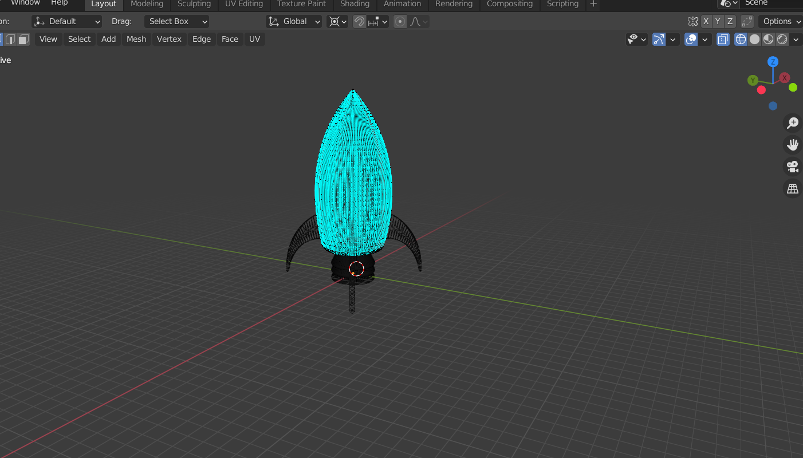

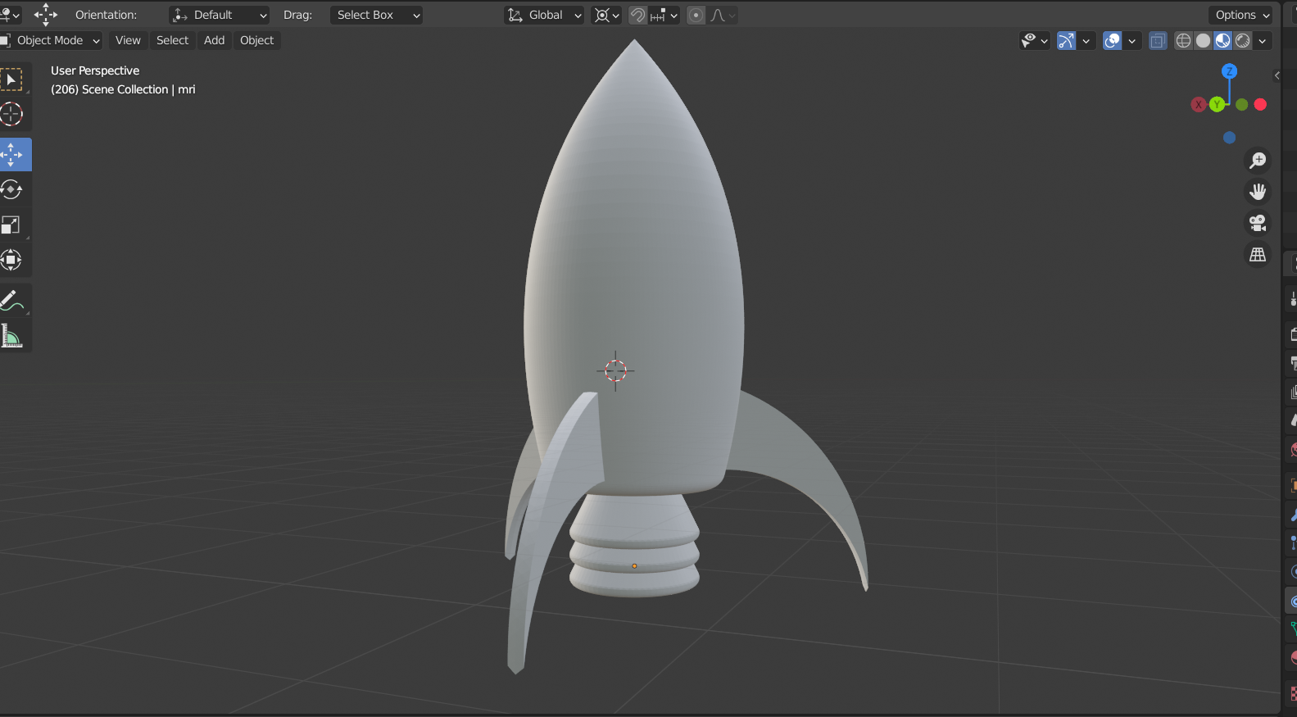

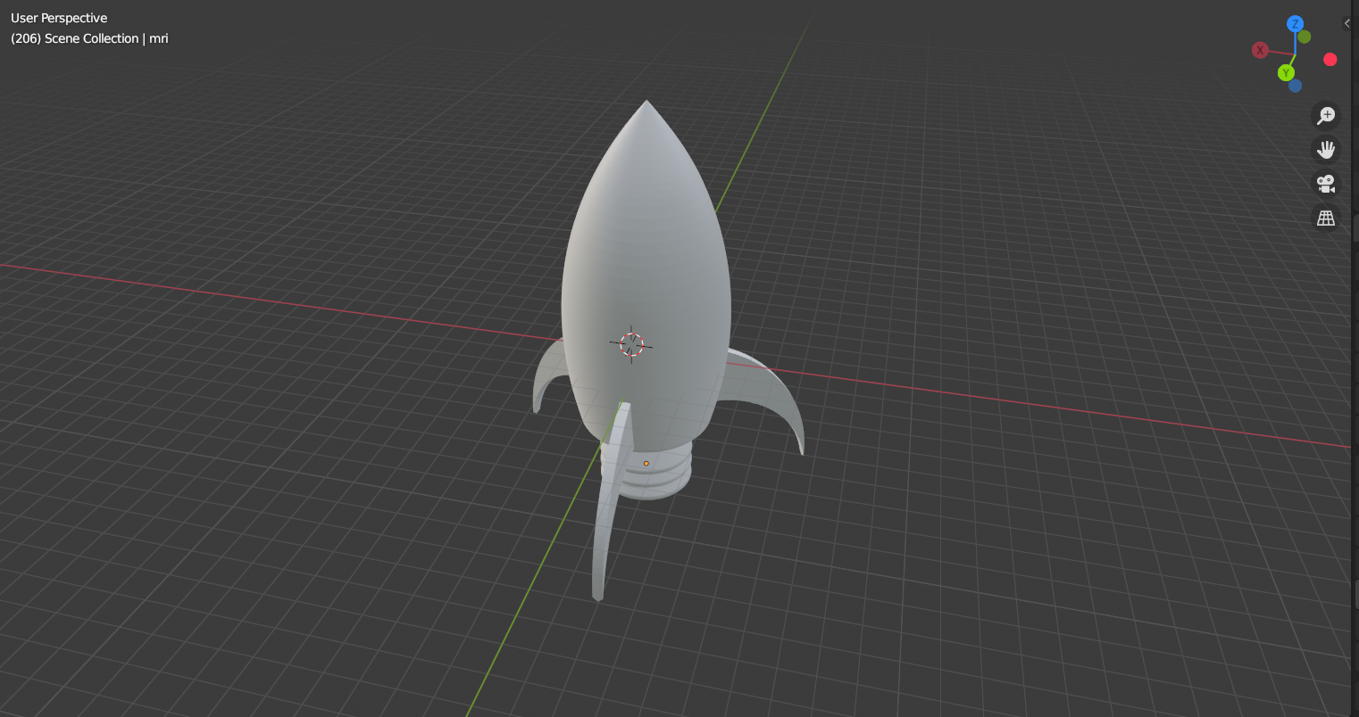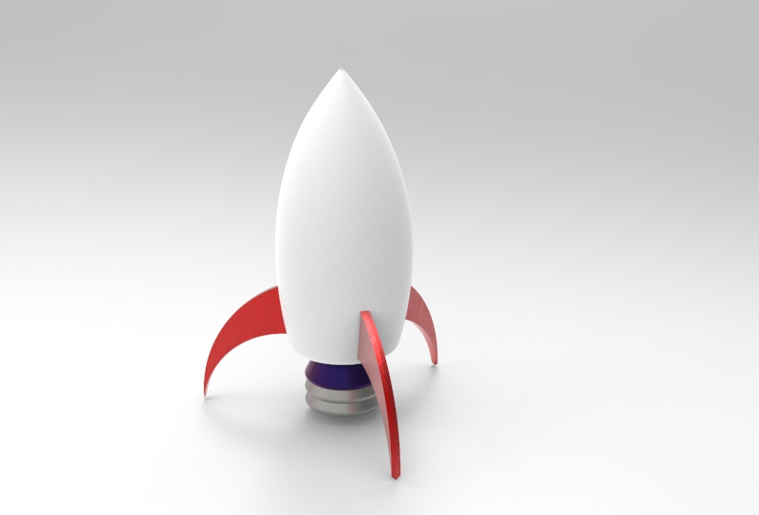

[**Link to Experiment**](https://drive.google.com/drive/folders/1flTmZIImByf3y0i2nJoYBXPXMLePEHfe?usp=sharing)